Overdale Community Primary School
Year 4 Spring Term 1 - 2024
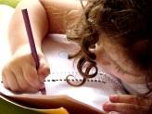  Literacy  In our Talk 4 Writing this half term our fiction focus will be writing warning stories including dialogue. We will use our new text ‘Staying Out’ to help guide us through our writing. Our non-fiction text will be an explanation text where will focus on using diagrams, bullet points and linking paragraphs with a range of conjunctions. | 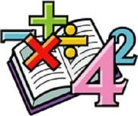  Maths  In maths, we will begin to calculate the perimeter of simple shapes and then strategies to calculate the perimeter of rectilinear shapes. We will the move on to our fractions unit, where the children will learn about equivalent fractions and adding and subtracting fractions. | Science  Sound is our focus in science this half term. We will be how sounds are made and how vibrations affect how sounds travels and its volume. We will also investigate the properties of the objects making the sound. | Computing  We will continue our learning about coding using the Scratch programme and will begin looking at computational thinking and programming.
Humanities  In humanities we are going to explore what life was like in Victorian times, as a significant time in our history and how this affects our lives today. | Our class book  The Boy Who Met a Whale  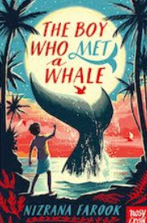 |  | PSHE  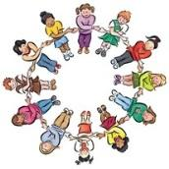  In PSHE, we will be thinking about citizenship. And human rights. We will look at the importance of communities and why we should look after and care for our environment.
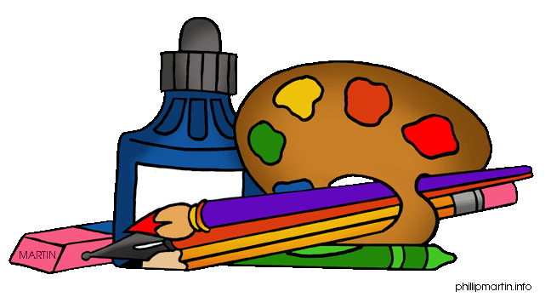  Art  In art this half term, we will be focusing on artists Laura Carlin and Shaun Tan. We will be using chalk and charcoal to create light and shadows. We will also use wax resist to create observational and experimental drawings. | PE  For games this half term, we are learning the skills involved in tag rugby and in gymnastics, we will be experimenting with pushing and pulling to create sequences and symmetrical patterns with a partner. | French  In French, we will extend our learning of the numbers in French as well as learning the days, months and various celebrations that take place across the year. | RE  In RE, we will learn about the importance of Festivals in religious communities.  Music  To identify different musical features and describe a musical piece using sounds and words. We will then create our own piece of music to celebrate Hanami.

